2nd National Congress on Computational Mechanics - Chania 1996

SIMULATION and CALCULATIONS on the CARDIAC PUMP

Dr. D.E. Ventzas, Mech & Electr Eng. (MISA, MIEEE)
Professor of Control & Instrumentation
Department of Electronic Eng, TEI Lamia

ABSTRACT: The paper models the heart
pumping mechanism as a 4-tank control problem
and uses control simulation techniques within the
parameters range to model and derive flow and
pressure curves similar to the physiological ones.

KEYWORDS: Cardiac pump, flow, pressure,
hydraulic model, cardiac output, simulation.

1. INTRODUCTION: The paper models the heart pumping mechanism as a 4-tank control problem and uses control simulation techniques within the parameters range to model and derive flow and pressure curves similar to the
physiological ones. Fig. 1, shows the cardiac anatomy, while in fig. 2, we get a

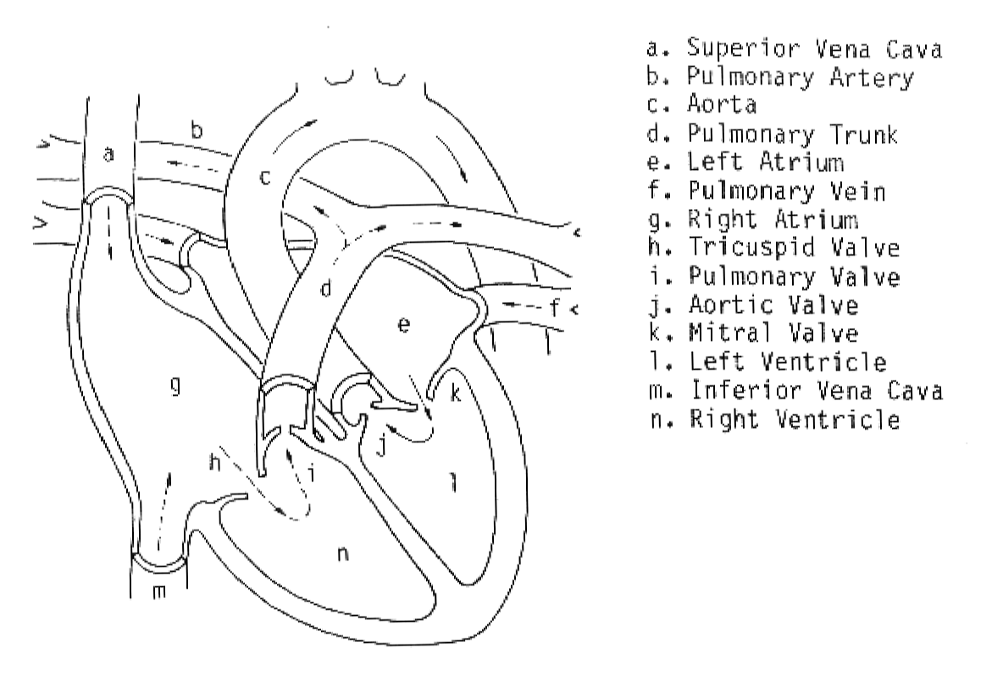

Fig. 1. The anatomy of the cardiac muscle as a blood pump

a simplified hydraulic model of the circulatory system including heart.
The characteristic parameters of the cardiac operation at rest and during labour in Table 1.
LABOUR  (kg.m/min) | CONSUMED  O₂ (mL/min) | BEAT  FREQUENCY | CARDIAC  SUPPLY (L/min) | BEAT  VOLUME (mL) | ARTERIAL-to-VEINO₂(mL/dL) difference
rest | 267 | 64 | 6.4 | 100 | 4.3
288 | 910 | 104 | 13.1 | 126 | 7.0
540 | 1430 | 122 | 15.2 | 125 | 9.4
900 | 2143 | 161 | 17.8 | 110 | 12.3
1260 | 3007 | 173 | 20.9 | 120 | 14.5

Table 1. Cardiac operation critical parameters (Asmussen et al, 1952)

Fig. 2. Pressure and flow variations in systemic circulation (Minlow, 1972)

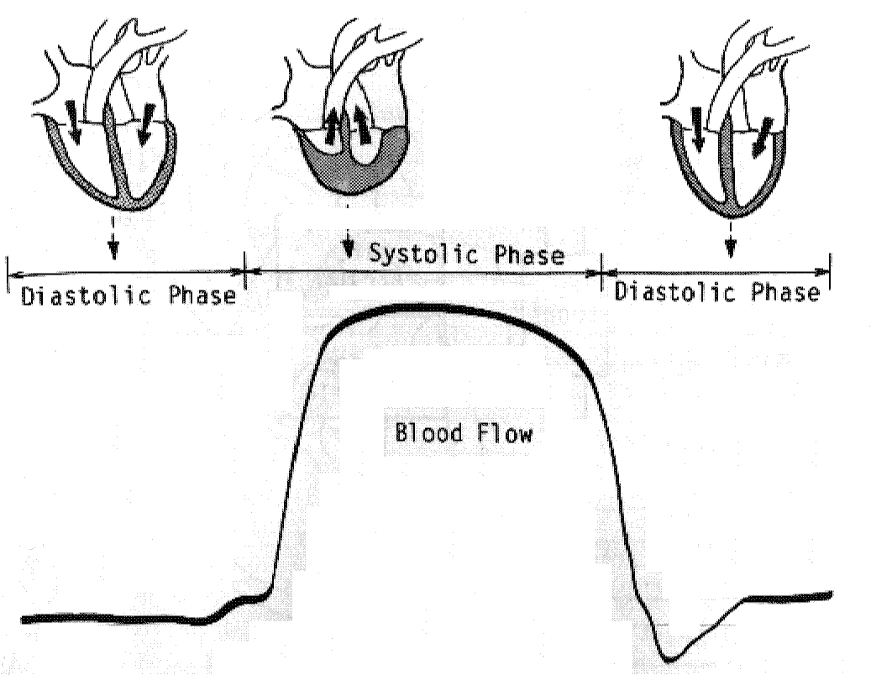

Fig. 3. Flow variations in systemic circulation (Hosaka, 1989)
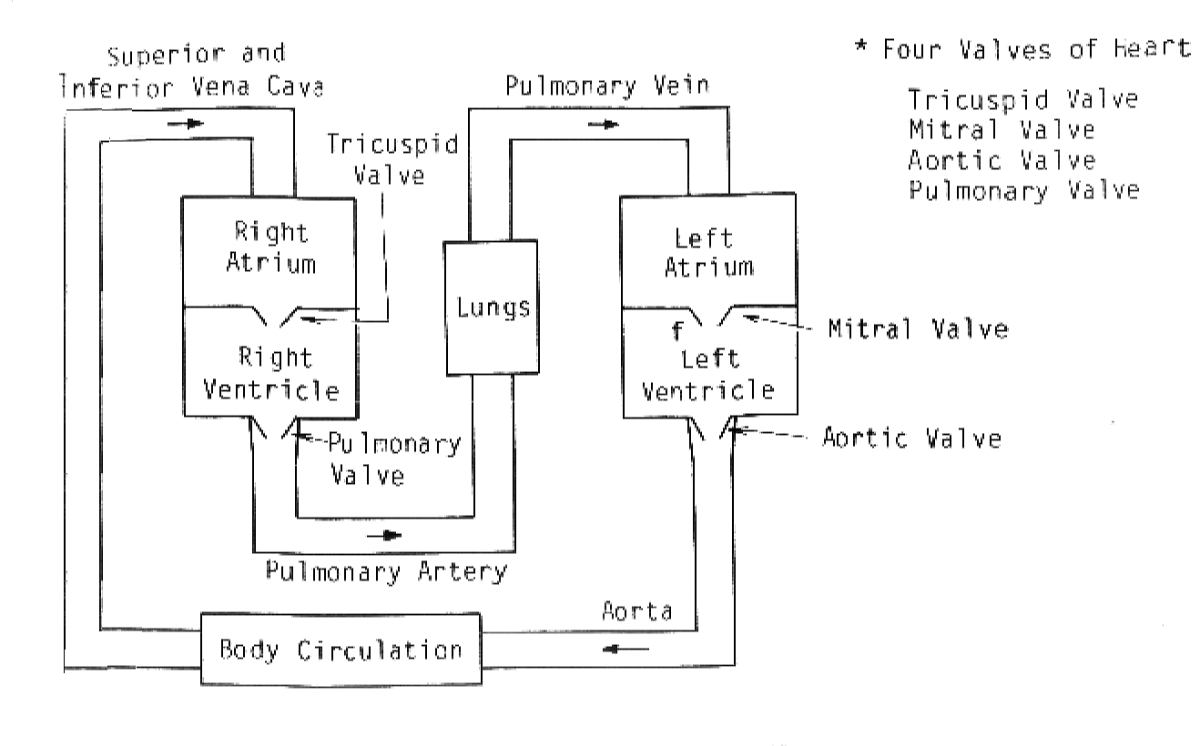

Fig. 4. Modeling of the blood circulation problem (Cromwell, 1980)

2. MODELING: Control system theory models the cardiac pump and the circulatory system as 4 - 6 cardiac mechanical valves, plus the flow restriction in the body and lungs (simulated by valves) and a pump positioned at the right attrium; in reality the cardiac muscle behaves like a distributed pumping mechanism. Level or pressure control in interconnected tanks example corresponds to volume (normalized to maximum cardiac chamber volume) or pressure control.
In the following 4 - tanks hydraulic model RA, RV, LA, LV, SIVC, PA, PV, A indices correspond to right atrium, right ventricle, left atrium, left ventricle, superior inferior vena cava, pulmonary artery, pulmonary artery, pulmonary vein, artery (Ganoong, 1985).

$P_{\text{SIVC}}(s)=\frac{R_{\text{TV}}}{R_{\text{TV}}\text{.}c_{\text{RA}}\text{.}s+1}\text{.}F_{\text{RA}}(s)+\frac{1}{R_{\text{TV}}\text{.}c_{\text{RA}}\text{.}s+1}\text{.}P_{\text{RA}}(s)$

P_{RA}(s) $\frac{1}{R_{\text{TV}}\text{.}c_{\text{RA}}\text{.}s+1}$

+ +
F_{SV}(s) K $\frac{R_{\text{TV}}}{R_{\text{TV}}\text{.}c_{\text{RA}}\text{.}s+1}$ + P_{SIVC}
-

Fig. 5. Closed loop control of right atrium

P_{RA}(s) $\frac{1}{R_{\text{PV}}\text{.}c_{\text{RV}}\text{.}s+1}$

+ + P_{PA}
F_{SV}(s) K $\frac{R_{\text{TV}}}{R_{\text{TV}}\text{.}c_{\text{RA}}\text{.}s+1}$ $\frac{1}{R_{\text{TV}}}$ $\frac{R_{\text{PV}}}{R_{\text{PV}}\text{.}c_{\text{RV}}\text{.}s+1}$ +
-

Fig. 6. Closed loop control of right atrium and right ventricle

The same models applies for the closed loop control of the left atrium and left ventricle.

P_{PV}(s) $\frac{1}{R_{\text{AV}}\text{.}c_{\text{LV}}\text{.}s+1}$

+ + P_{A}
F_{SV}(s) K $\frac{R_{\text{MV}}}{R_{\text{MV}}\text{.}c_{\text{LA}}\text{.}s+1}$ $\frac{1}{R_{\text{MV}}}$ $\frac{R_{\text{AV}}}{R_{\text{AV}}\text{.}c_{\text{LV}}\text{.}s+1}$ +
-

Fig. 7. Closed loop control of left atrium and left ventricle
Combining the above models of right and left cardiac chambers we conclude the model shown in fig. 6, that corresponds to the whole blood circulatory system, including the cardiac pumping mechanism.

In this model we do not take into account (in the strict mathematic sense):
a. nonlinear effects of valves, etc
b. delay effects of pipelines
c. blood filling volumes of arteries and veins
d. blood filling volumes of lungs and body
e. arteries’ and veins wall elasticity
f. compressibility of fluids
g. multiphase nature of blood
h. distributed effects of all the above parameters

$\frac{1}{R_{B}}$

P_{RA}(s)
$\frac{1}{R_{\text{PV}}\text{.}c_{\text{RV}}\text{.}s+1}$

+ + P_{PA}
F_{SV}(s) K $\frac{R_{\text{TV}}}{R_{\text{TV}}\text{.}c_{\text{RA}}\text{.}s+1}$ $\frac{1}{R_{\text{TV}}}$ $\frac{R_{\text{PV}}}{R_{\text{PV}}\text{.}c_{\text{RV}}\text{.}s+1}$ +
-

$\frac{1}{R_{L}}$

P_{PV}(s) $\frac{1}{R_{\text{AV}}\text{.}c_{\text{LV}}\text{.}s+1}$

+ + P_{A}
F_{SV}(s) K $\frac{R_{\text{MV}}}{R_{\text{MV}}\text{.}c_{\text{LA}}\text{.}s+1}$ $\frac{1}{R_{\text{MV}}}$ $\frac{R_{\text{AV}}}{R_{\text{AV}}\text{.}c_{\text{LV}}\text{.}s+1}$ +
-

Fig. 8. Closed loop control of right/left atrium and right/left ventricle

The above control model of the cardiac pump as interconnected tanks, see fig. 8, is simulated with MATLAB (MathWorks, 1990, Scholz, 1994) by the SIMULAB configuration of fig. 9. The cardiac model shouuld be excited by electric stimulus at sinus attrium, simulated by sinusoidal or triangular electric signal excitation, at the appropriate node. The results are presented in fig. 11.

3. CONCLUSIONS: The paper presented the main parameters of cardiac activity as a pump; it modelled blood flow and heart chambers and valves as interconnected tanks, by control systems theory. Simulation results are presented. More detailed signal reconstruction is needed; this can be focused on valves action simulation and arteries non-linear effects. This work is part of a global computational job on heart pumping action and blood circulation fluid dynamics (Fung, 1984), performed by the author, see fig. 10 (Spiropoulos et al, 1992, Ventzas, 1992 & 1995).

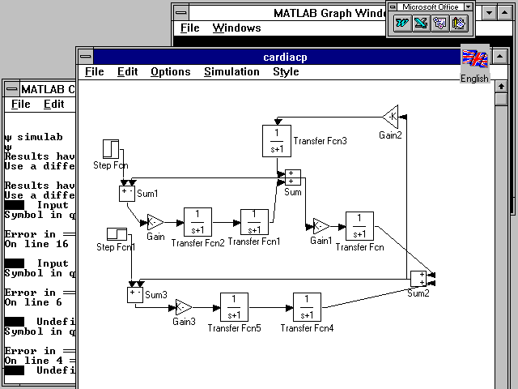

Fig. 9. Matlab-Simulab cardiac pump simulation enviroment

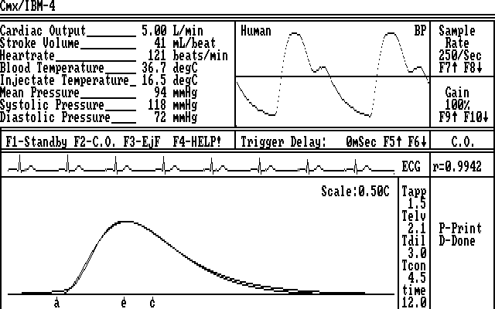

Fig. 10. Cardiac output and blood pressure intensive care unit display

REFERENCES
[1] Asmussen, E, Nielsen, M, The cardiac output in rest and work
determined by the acetylene and de injection methods, Acta Physiol.
Scand, 1952, vol. 27, p. 217

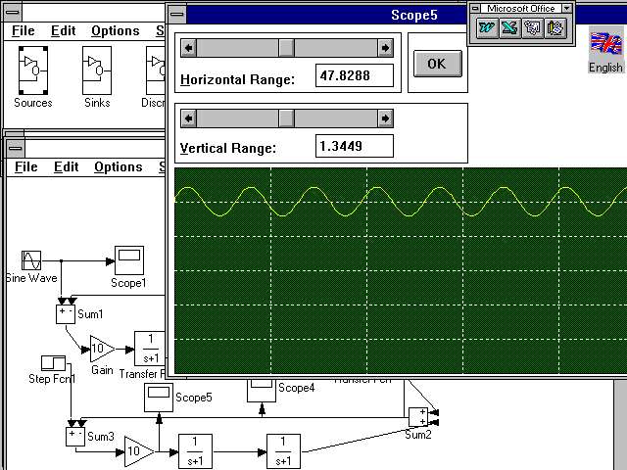

Fig. 11. Output of simulated flow of cardiac activity

[2] Cromwell, L, Weibell, F. J, Pfeiffer, E. A, Biomedical Instrumentation
and Measurements, Prentice Hall, 1980
[3] Fung, Y. C, Biodynamics of Circulation, Springer-Verlag, 1984
[4] Ganong, W. F, Review of Medical Physiology, 11th edition, Lange
Medical Publications, 1985
[5] Hidehiro Hosaka, A Basic Guide to the ECG, Nihon Kohden, PMS
Technical Education Series, 1989
[6] MATLAB, Operating Manual, MathWorks, 1990
[7] Minlow, W. R, Pulsatile Blood Flow, N. Engl. J. Md, 1972, vol.287, p.27
[8] Scholz, H, Analog and Digital Simulation of Continuous Systems, Using
a Microcomputer and CSMP - Continuous System Modeling Program,
Fachhochschule Darmstadt, Fachbereich Informatik, 1994
[9] Spiropoulos, B, Ventzas, D, Biomedical Instrumentation I, TEI Athens,
Athens,1992 (in Greek)
[10] Ventzas, D, Bio-Automation I-II, TEI Athens, Athens,1992 (in Greek)
[11] Ventzas, D, Digital Control, Control Theory, Vol. 2, Lamia, (in Greek),
1995

⎯⎯⎯⎯⎯⎯⎯⎯⎯⎯⎯⎯⎯⎯⎯⎯⎯⎯⎯⎯⎯⎯⎯⎯⎯⎯⎯⎯⎯⎯⎯⎯⎯⎯⎯⎯⎯⎯⎯⎯
Dr. D.E. Ventzas (MIEEE, MISA) is an Electronic - Instrument Eng; he obtained an M.Sc. in Control Eng. and Ph.D. in Microprocessor-based Instrumentation at Bradford University, P/G School of Control Eng, W. Yorkshire, UK; he was Head of Biomedical Instrumentation Dpt, at Technological and Educational Institute TEI of Athens, Greece. He was a teaching lecturer for Control, Robotics, Measurements, Stochastic Processes at University of Thessalia, Mechanical Eng. Dpt, Volos, Greece. In 1993 he was appointed Professor in Control and Measurements at TEI Lamia, Central Greece.
⎯⎯⎯⎯⎯⎯⎯⎯⎯⎯⎯⎯⎯⎯⎯⎯⎯⎯⎯⎯⎯⎯⎯⎯⎯⎯⎯⎯⎯⎯⎯⎯⎯⎯⎯⎯⎯⎯⎯⎯

