Signal Procesing and Pattern Recognition Aspects in Information Systems Modeling via Step Response Methods

D. Ventzas*, C. Karapoulios*, C. Kalovrektis*

*ΤΕΙ Larisa, STEF, Informatics & Telecommunications Eng. Dpt,
Larisa 41 110, e-mail: ventzas@teilar.gr

ABSTRACT

The paper presents signal processing, pattern recognition and artificial intelligence aspects in modeling information systems methods. The step response of all control parameters under various control conditions and problems gives a better understanding in real phenomena and diagnostic cases, such as stochastic system inherent nonlinearities, system frequency content, or sensor characteristics ambiguities (such as micro nonlinearities, multi-valued functions, variable noise, . Emphasis is given in the time domain for industry, since time is dominant in industrial control. Laplace and z-transform does not prevail expert knowledge and heuristics rules.

INTRODUCTION

In this research work we classify cases and patterns in systems modeling and control responses for diagnostics and artificial intelligent purposes. Intelligent controllers with such built-in expert knowledge can identify cases and patterns for optimal control and decision-making. Such examples are given below with some introductory comments. The work emphasizes on signal processing of system responses. Curve identification relies on special features such as patterns of line crossings, or dominant lines, or even special responses in the training set.
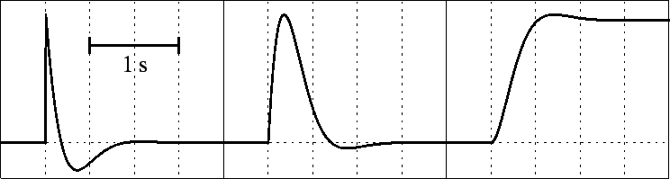

Fig.1. Normalized step responses for 2nd order system with high- band- low- pass characteristics
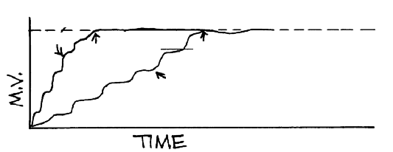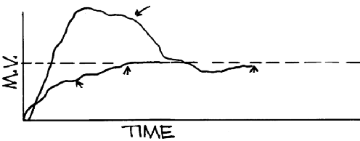
(a) (b)
Fig. 2. Actuator output response for high skilled (a) and non experienced (b) technician
with multiturn / single-turn settability and resolution
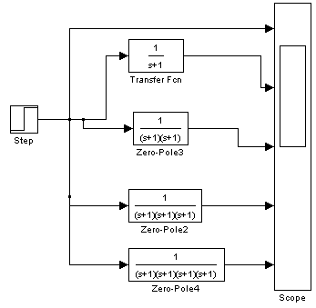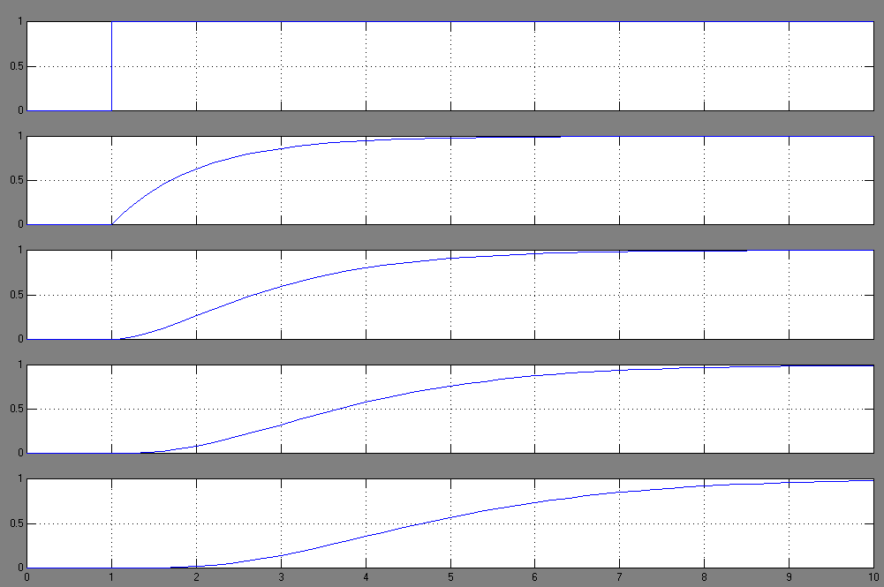

Fig. 3. Step responses for 1st, 2nd, 3d, 4th order systems

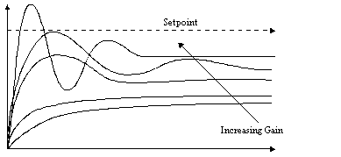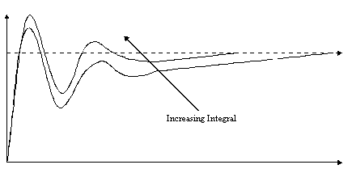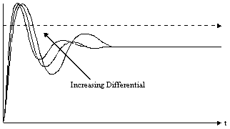

Fig. 4. System responses under pure P, I and D actions

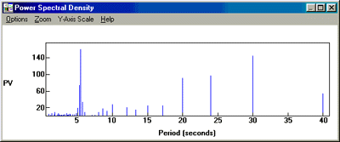

Fig. 5. Spectral components of step response. Spectrum analysis is substituted
by simple trend (tangential) detection subroutines due to requirements of speed for calculations.

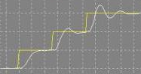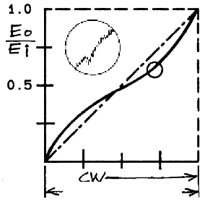

Fig. 6. Obvious on-linear response under PID control with certain PID parameters
under various step conditions (a) and sensor micro non linearity with noise (b)
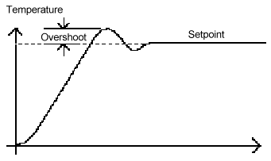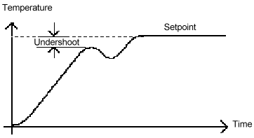
Fig. 7. Overshooting and undershooting due to over or under control action
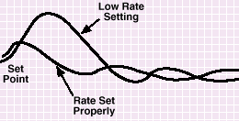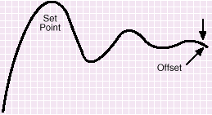
Fig. 8. The differential (rate) action compensates for abrupt load variations reducing overshoot
and undershoot, while the integral action eliminates offset
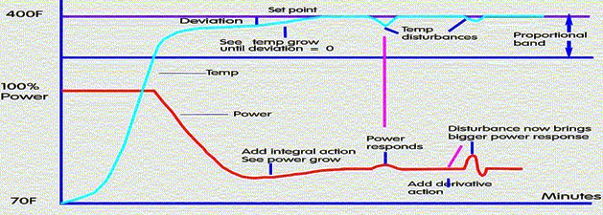 Fig. 9. System’s output response (PV) and controller output (MV)
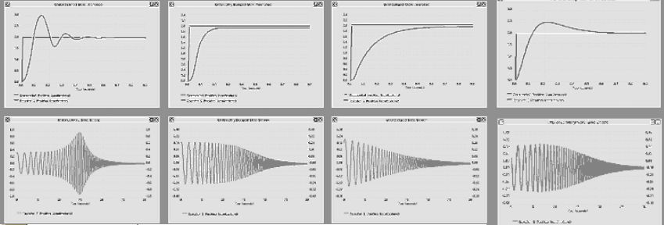
Fig. 10. The integral action underdamped (subcritical), critical and overcritical (overdamped) systems

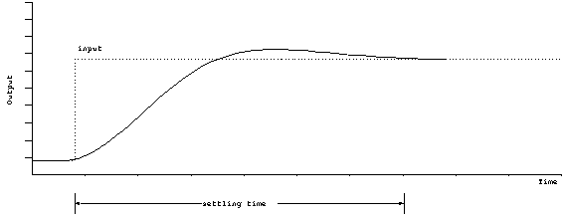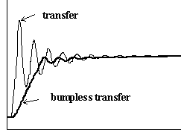
Fig. 11. Optimal (in speed) system response (a) and bumpless transfer (b); bumpless transfer is a general philosophy in control action transfer, but in case of cascade control it means the output of master always follows the slave’s input (MV₂ = SV₁) , leading to non oscillatory control action transfer from automatic (single controller) to cascade (double controller) transfer

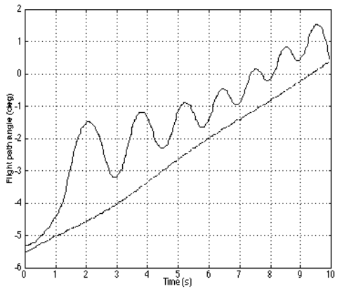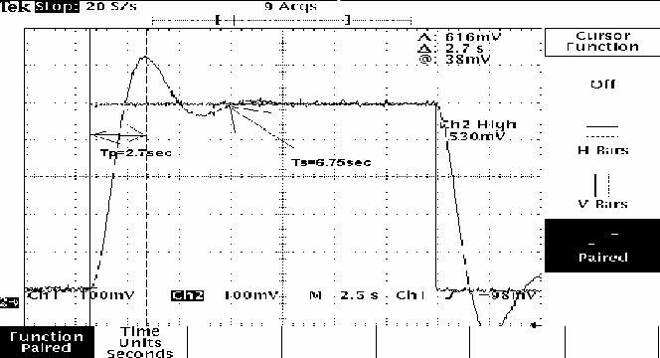

Fig. 12. Control effort of air-to-air missile with sliding behavior
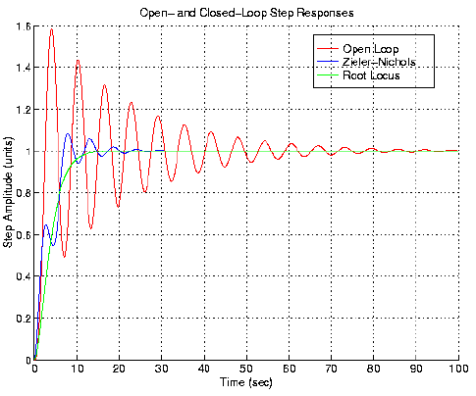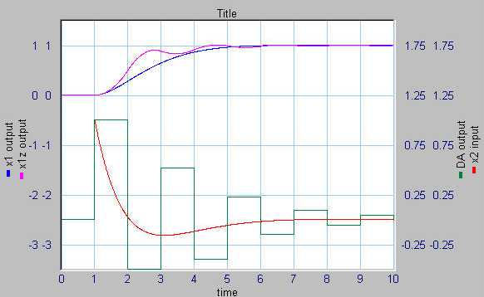

Fig. 13. Response and settling time (a) Digital response of PV and MV with discrete control action (b)

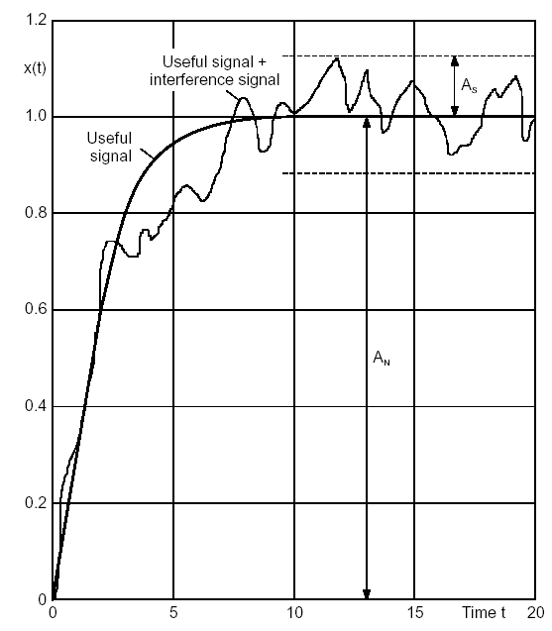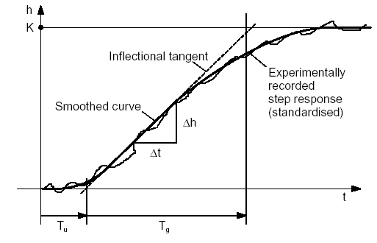

Fig. 14. Response curves and noise and the tangential method of response follow up

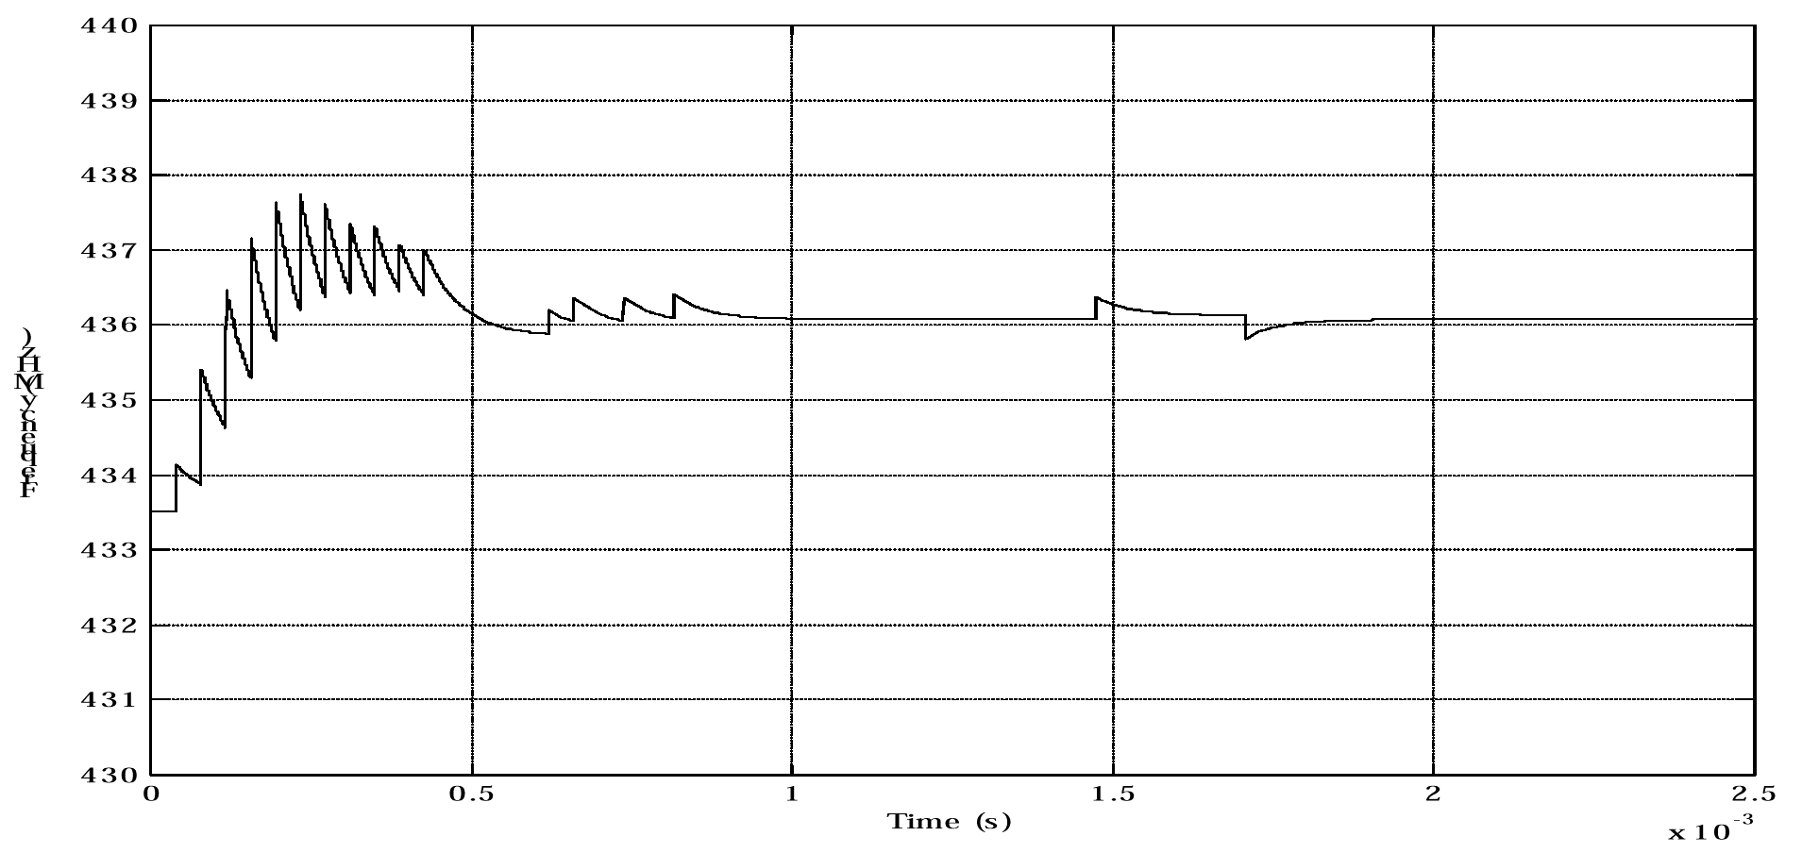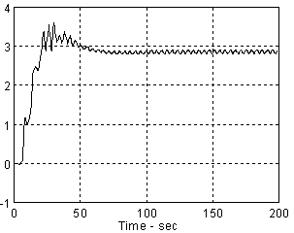
Fig. 15. PLL driven (a) and fuzzy (b) oscillations in control applications

